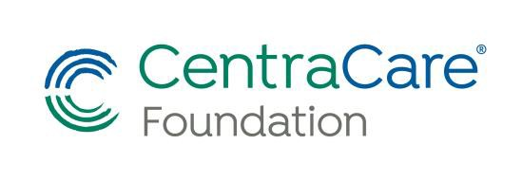

2026 High School Health Care Scholarship
Provided by CentraCare Foundation
CentraCare Foundation – Cedar Mountain Scholarship program was established to encourage and promote qualified individuals from the hospital’s service area to pursue a healthcare career. The scholarship will aid in funding education at any accredited training program at any college or university. Recipients are selected using a selection process from the eligibility criteria as stated below. Awards are made without regard to race, color, creed, religion, sex, disability, national origin, or financial need. Incomplete applications will not be considered.

Award:
One (1) $500 scholarships will initially be awarded annually. One $500 check will be made to each recipient at the beginning of the second quarter/semester, after CentraCare Foundation - Cedar Mountain receives the required documentation. The scholarship is to be used for tuition, fees and/or books anytime during the recipient’s healthcare program. If a recipient decides to no longer pursue in a health-related career prior to their second quarter/semester, award
monies will be forfeited to CentraCare Foundation – Cedar Mountain Scholarship Fund.

Applicant Criteria:
- Must be a graduating high school senior in the CentraCare– Redwood Falls service area from Cedar Mountain High School.
- Has a minimum high school cumulative grade point average of 3.0 on a 4.0 scale.
- Is pursuing a health-related career.
- Has prior experience in a health related program such as Healthcare Career Class, hospital or nursing home job or volunteer work.
- Participates in community activities.
- Estimated financial need. (estimated cost of schooling)

Application Procedure:

The following materials must be completed and handed in to Mr. Palokangas by MAY 13, 2026:
- Completed and Signed Application Form. Please print or type.
- Short Essay describing interest in health related field, not to exceed 500 words.

STUDENT DATA:
Last Name | First Name |  | Middle Initial
Phone Number
Home Address
Parents
High School

HEALTHCARE PROGRAM DATA:
College or University
Address

Phone
Healthcare Program
Length of Program |  | Anticipated Start Date
APPLICATION INFORMATION:
Cumulative Grade Point Average (G.P.A. on scale of 4.0) |  |  |  | Class Rank | %
List prior health related jobs or volunteer program involvement:
List academic and special recognition:
List school activities and participation:
List community activities and service:

FINANCIAL INFORMATION:
Estimated annual cost of program including tuition, books, supplies, etc. (Do not include costs such as housing, food, transportation, etc.)
Complete the following graph by listing known information and checking boxes appropriately.
Grant(s) and/or Scholarships(s) Dollar Amount | Received | Pending | Expected Date or Notification
 | Yes No | Yes No
 | Yes No | Yes No
 | Yes No | Yes No
 | Yes No | Yes No
PERSONAL STATEMENT:
Write a Personal Statement describing your career goals, leadership abilities and why you selected this healthcare program. The personal statement should not exceed 500 words.
Please attach typed Personal Statement

Applicant Signature:

I certify that the above information is correct.

Applicant: Date:

