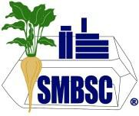

Southern Minnesota Beet Sugar Cooperative

83550 County Road 21, Renville, Minnesota 56284

To: SMBSC Area High Schools From: SMBSC Scholarship Committee Date: January 27, 2026

Southern Minnesota Beet Sugar Cooperative is offering scholarships to students who plan to pursue their education beyond high school graduation.

The following scholarships will be awarded:
- One (1) $1,500 scholarship to an immediate family member of a SMBSC Shareholder.
- One (1) $1,500 scholarship to an immediate family member of a SMBSC Employee.
- Four (4) $1,000 scholarships to an immediate family member of a SMBSC Shareholder or Employee.

Scholarships will be issued upon proof of enrollment in the second quarter, semester, or term of the 2026/2027 college year.

We realize this scholarship does not apply to your entire student body; however, we want to ensure our potential applicants are aware. Could you please post this scholarship along with all other scholarships available to your students? The scholarship qualifications and application are attached.

The deadline to submit a completed application is Monday, March 2, 2026.

info@smbsc.com | www.smbsc.com

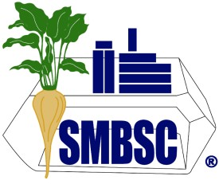
Southern Minnesota Beet Sugar Cooperative
S M B S C S C H O L A R S H I P Q U A L I F I C A T I O N S
2026

Southern Minnesota Beet Sugar Cooperative is offering scholarships to students who plan to pursue their education beyond high school graduation.

The following scholarships will be awarded:
- One (1) $1,500 scholarship to an immediate family member of a SMBSC Shareholder.
- One (1) $1,500 scholarship to an immediate family member of a SMBSC Employee.
- Four (4) $1,000 scholarships to an immediate family member of a SMBSC Shareholder or Employee.

SMBSC Scholarship Program Requirements
In order to be eligible for the SMBSC Scholarship program, the applicant must:
  - Be a dependent child of SMBSC Shareholder or Employee at time of application deadline
  - Have a least a 2.00 cumulative grade point average (GPA) on a 4.00 scale (e.g. high school record for incoming freshman or post-secondary school record for those already enrolled in a college, university, or vocational or technical school)
  - Be a freshman, sophomore, or junior in the Fall of 2026 enrolled at a two- or four-year college or university, or vocational or technical school (i.e. no graduate or PH. D work)
  - Student can only be awarded a scholarship once; however, they may reapply in subsequent years as long as the student was not awarded the scholarship previously
  - Scholarship payment must be used for the spring semester of the 2026-2027 school year
  - Incomplete application packages will not be evaluated
  - Candidates may be interviewed

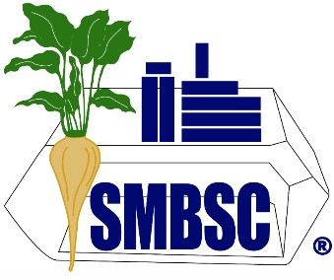

Applicant Name (last, first middle):
Mailing Address:
City, State and Zip Code: Telephone Number: Email Address: Scholarship Applied For:
Shareholder/Name
Employee/Name

Southern Minnesota Beet Sugar Cooperative
2026 Scholarship Application

Application Question:
Please submit a one page typed statement of interest discussing your career interest and career goals including what attracted you to this field, related work and volunteer experiences, what you want to accomplish as well as how this scholarship will help you meet these goals, and what makes you a strong applicant for the SMBSC scholarship.
DO NOT INCLUDE NAMES OF YOURSELF OR FAMILY MEMBERS IN YOUR STATEMENT OF INTEREST.

Application is complete and valid when you submit all of the following materials:
Completed Scholarship Application Form Statement of Interest
Official School/College Transcript (Freshman in college include your high school transcript.)

Please note:
Candidates may be interviewed.
Incomplete application packages will not be evaluated.
Please refer to the SMBSC Scholarship Qualifications for additional requirements.

Applicant Signature: Date:

Print and Mail to: | Liza Fagen
Southern Minnesota Beet Sugar Cooperative
83550 County Rd 21
Renville, MN 56284

Application Deadline: Monday, March 2, 2026

